**EXPERIMENT NO. 2**

**Aim:** Write commands to create a table called ‘cricket’ and insert rows ‘f_name’, ‘s_name’, ‘runs’, ‘age’

and perform basic SQL operations

**CODE:**

**i) Entering records into the table and displaying them**

select * from CRICKET;

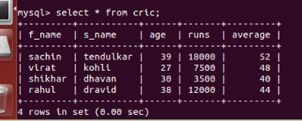

**ii) selecting records based on some criteria using the WHERE command**

select * from CRICKET where age<40 AND avf>40;

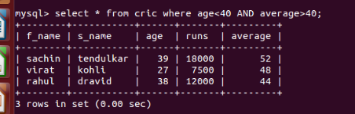

**iii) Sorting the table on the basis of runs scored**

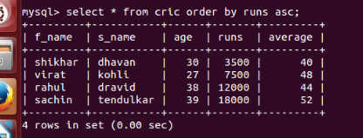select * from CRICKET order by runs asc;

**iv) using the ‘IN’ command**

select * from CRICKET WHERE age IN(‘38’,’39’,27);

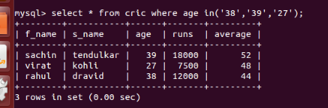

**v) implementing select command using ‘LIKE’ command**

select * from CRICKET where S_name LIKE(‘%a%’);

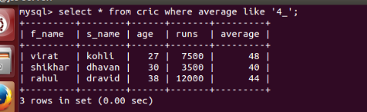 select * from CRICKET where S_name LIKE(‘d%’);

**EXPERIMENT NO. 3**

**Aim:** To perform various SQL command

**CODE:**

1)display all the element of database

->Mysql>select * from cric;

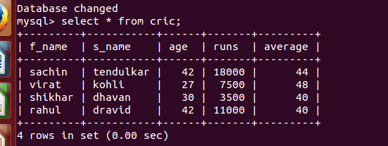

2)display maximum run and age of cricketer from database

->Mysql>select max(run) from cric;

->Mysql>select max(age) from cric;

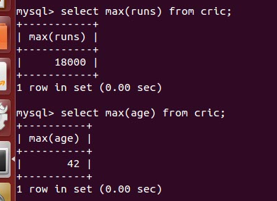

3)display minimum age of cricketer from database

->Mysql>select min(age) from cric;

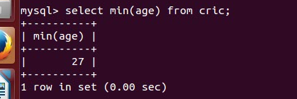

4) display number of attributes from database

->Mysql>select count(*) from cric;

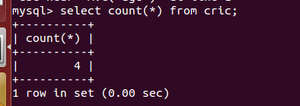

5) display average age of cricketer from the database

->Mysql>select Avg(age) from cric;

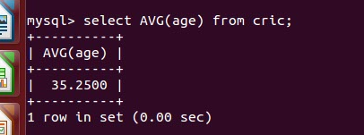

6) display name of cricketer in upper case from the database

->Mysql>select upper(f_name),upper(s_name) from cric;

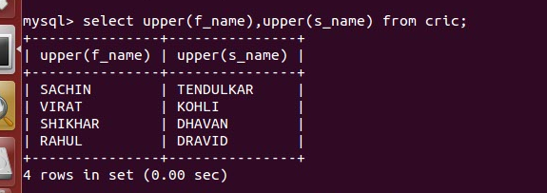

7) display name of cricketer in lower case from the database

->Mysql>select lower(f_name),lower(s_name) from cric;

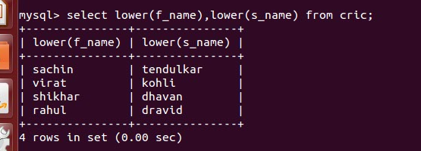

8) display name of cricketer in concatenated form from the database

->Mysql>select concat(f_name,’ ‘,s_name) from cric;

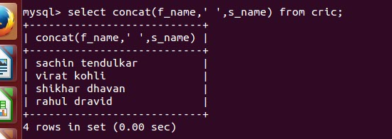

9) display a part of substring extracted from the database

->Mysql>select substr(f_name,2,4) from cric;

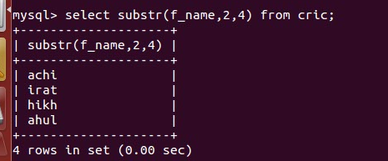

10) display name of cricketer by trimming white spaces from the left in the database

->Mysql>select ltrim(f_name) from cric;

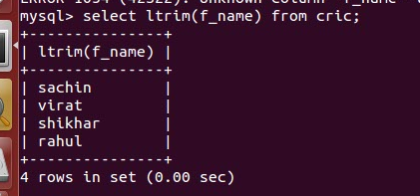

11) display sum of all ages of cricketer from the database

->Mysql>select sum(age) from cric;

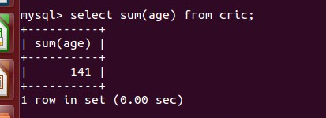

12) display name of cricketer after replacing character ‘s’ from ‘a’ in the name from the database

->Mysql>select repalce(f_name,’s’,’a’) from cric;

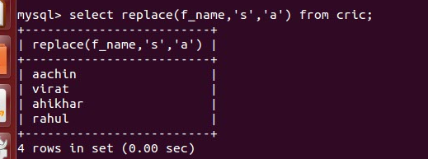

**EXPERIMENT NO. 4**

**AIM:** To get familiarise to Numeric Function AND Data Function

**(1) NUMERIC FUNCTION:**

**QUERY: 1:** To find the absolute value of number.

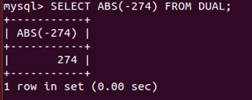

**2:** Find round-off value of number.

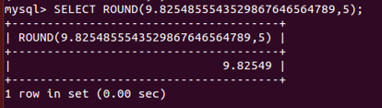

3: Use power function to find the result.

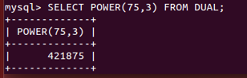

4: Find the square root of number.

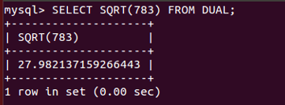

5: Find exponent value of number.

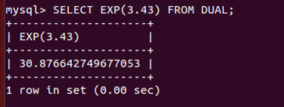

6: Find the greatest number among the list.

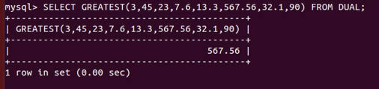

7: Find the least number among the list.

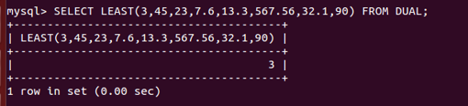

8: Display remainder of 15 when divided by 7.

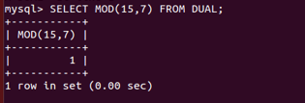

9: Use truncate function to find the final value.

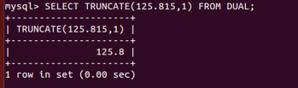

10: Display the smallest integer which is greater than 24.8.

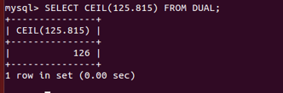

11: Find out the sine value of a number.

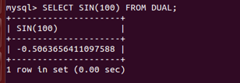

**(2) DATA FUNCTION:**

1: Add 4 months to system date and display it.

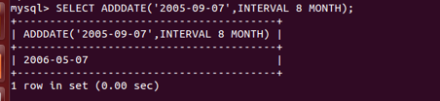

2: Find out the difference in month.

